PRIMARY 5 – PUPIL'S TEXT

TABLE OF CONTENTS

MODULE 1: FOOD, NUTRITION AND HEALTH

UNIT 1 Definition of foods, nutrition and health
UNIT 2 Food nutrients
UNIT 3 Food groups
UNIT 4 Nutritional needs of different age groups
UNIT 5 Diet related health risks and diseases

MODULE 2: EATING HABITS, CULTURAL AND SOCIAL INFLUENCES

UNIT 1 Eating habits and values
UNIT 2 Meals and meal patterns
UNIT 3 Food habits of different ethnic groups
UNIT 4 Factors influencing food choices

MODULE 3: FOOD AND EMOTIONAL DEVELOPMENT

UNIT 1 Sensory perception of foods
UNIT 2 Food preferences
UNIT 3 Body image and self esteem

MODULE 4: HYGIENE, SANITATION AND NUTRITION

UNIT 1 Water
UNIT 2 Food safety and hygiene
UNIT 3 Diarrhoea and other water borne diseases
UNIT 4 Waste disposal

MODULE 5: FOOD PREPARATION, PRESERVATION AND STORAGE

UNIT 1 Preparation techniques and skills
UNIT 2 Cooking techniques and skills
UNIT 3 Food preservation

MODULE 6: CONSUMER ASPECTS OF FOOD

UNIT 1 Food quality
UNIT 2 Food shopping
UNIT 3 Food packaging
UNIT 4 Advertising and marketing
UNIT 5 Consumption and environment

MODULE 7: FOOD PRODUCTION, PROCESSING AND DISTRIBUTION

UNIT 1 Food production
UNIT 2 Farms and gardens for improved nutrition
UNIT 3 Food processing
UNIT 4 Food and nutrition security
UNIT 5 Environmental aspects in food production and nutrition
UNIT 6 Emerging issues

MODULE 1: FOOD, NUTRITION AND HEALTH

Learning Objectives:
At the end of this module, pupils should be able to:
- Explain food, food nutrients, nutrition and health
- Classify food into different groups
- Explain the functions of food nutrients
- Outline the nutritional needs of different age groups
- List some health problems that could arise from taking too much or little food
- Explain how to calculate body mass index

UNIT 1: DEFINITION OF FOOD, NUTRITION AND HEALTH

Food
Food is anything liquid or solid, which when eaten could provide energy, help the body to grow and protect it against diseases.

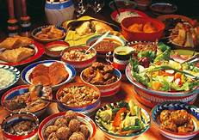

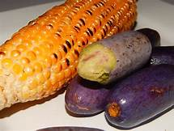

Different Foods

Nutrition
Nutrition deals with the food we eat, how the body digests, absorbs, uses and excretes the food substances.

Health
Health is when one is in a state of physical, emotional, social and mental well-being.Health is not just absence of illness. Adequate nutrition helps to keep the individual healthy.

Insert picture of a healthy person

A healthy person

UNIT 2: FOOD NUTRIENTS

Food Nutrients
Food nutrients are the substances in food that help the body to function well. Food nutrients include;
- Carbohydrates
- Proteins
- Fats and Oils
- Vitamins
- Minerals
- Water

FUNCTIONS AND SOURCES OF FOOD NUTRIENTS
- Carbohydrates: Carbohydrates provide energy needed by the body. Foods that are rich in carbohydrates include cassava, yam, cocoyam, potatoes, millet rice, wheat guinea corn and maize.

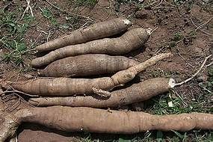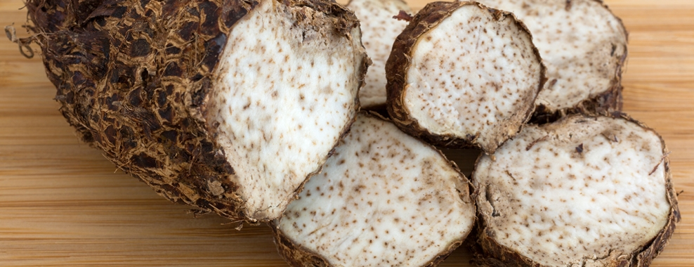

Pictures should be properly arranged and labelled

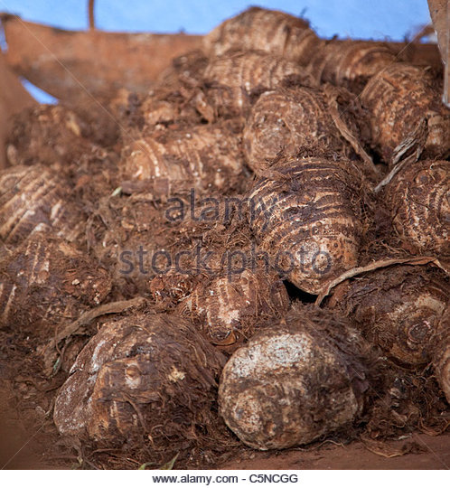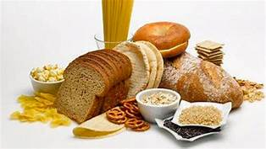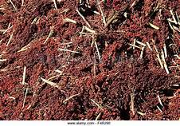
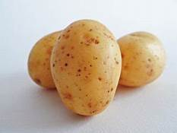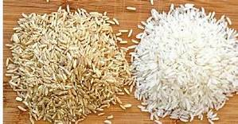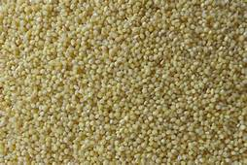

Carbohydrate rich Foods

- Proteins: Proteins are needed for growth and repair of cells. Foods that are rich in protein are milk, chicken, , meat, fish, egg, liver, snail, termite and other insects, nuts beans, and soybean.

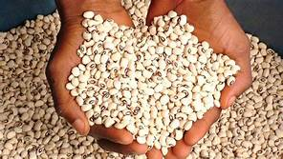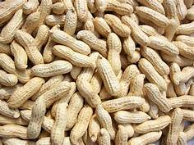
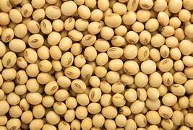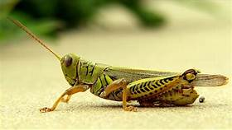
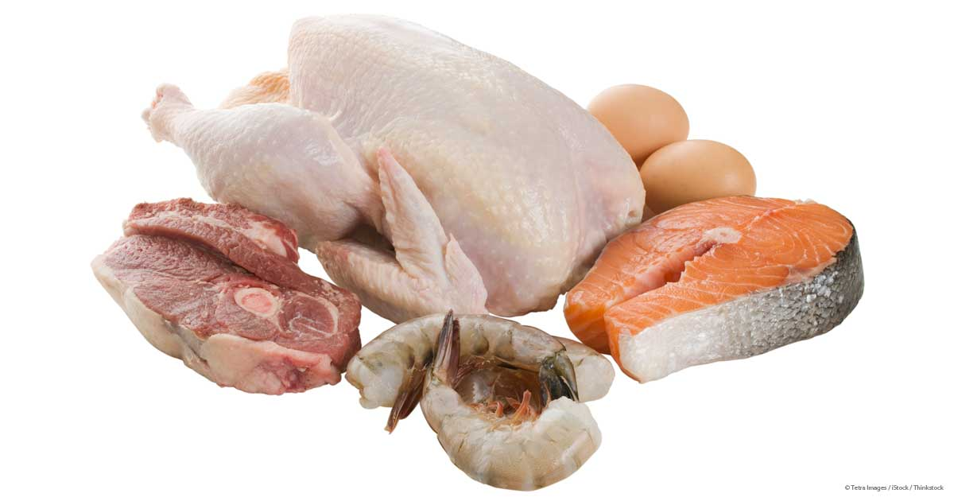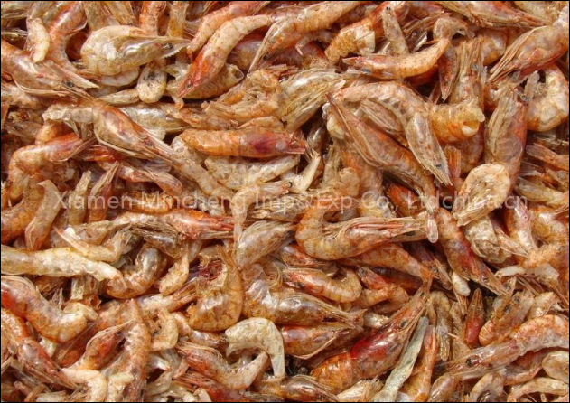

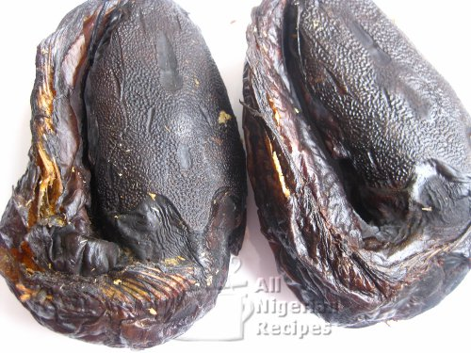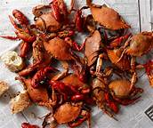

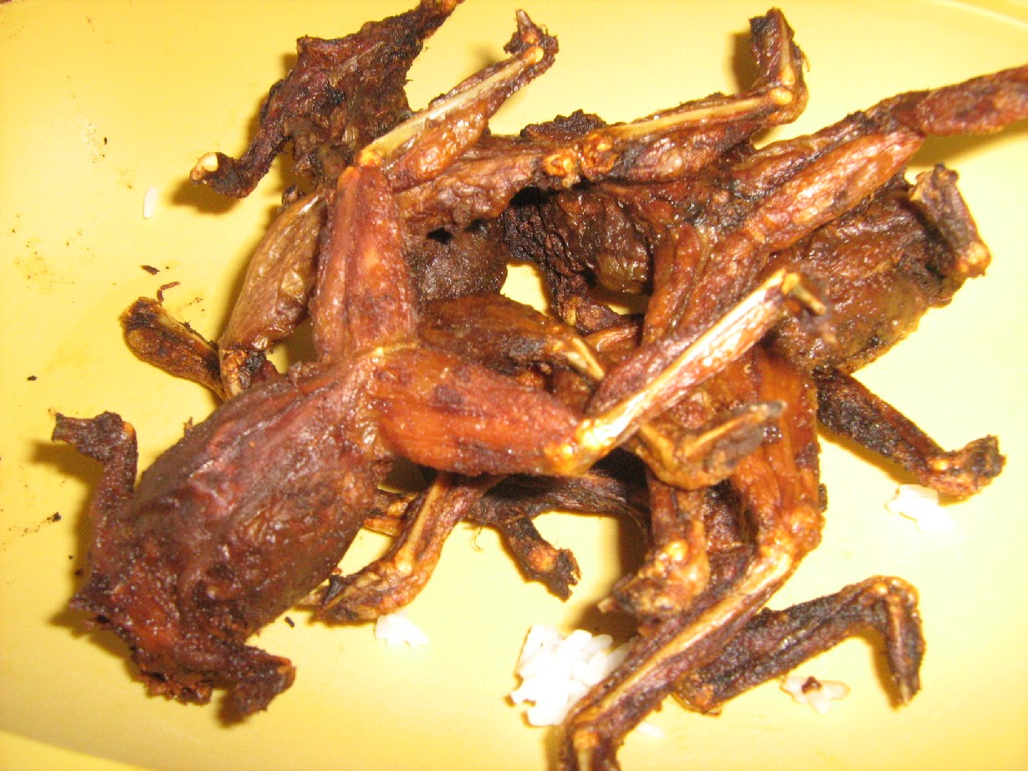delete and replace with snails

Protein Foods

- Fats and oils: Fats and oils provide energy and serve as carriers of fat soluble vitamins. Foods tha are rich in fats and oils include; palm fruits , groundnuts and cooking oils, butter, margarine,, cashew nuts and soybeans.

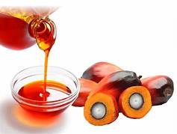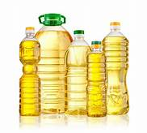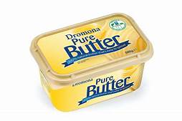Insert apropriate pictures
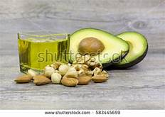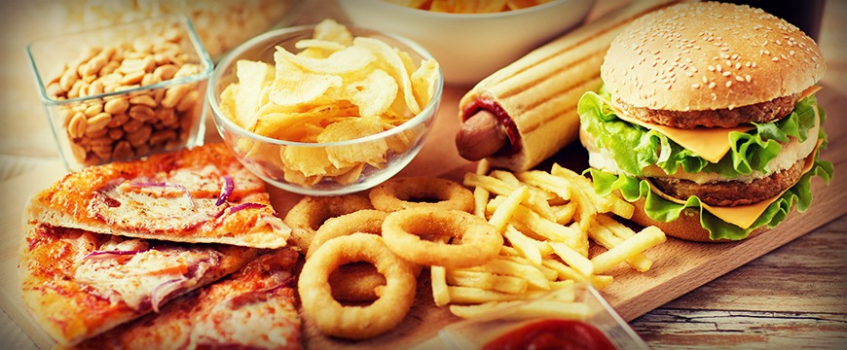delete junk

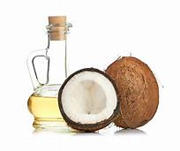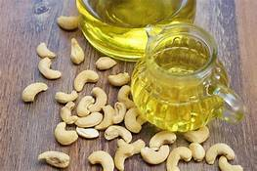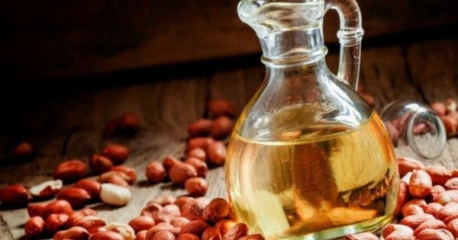Foods rich in Fats and Oils

- Vitamins : Vitamins are required for growth and maintenance of good health. Vitamins protect the body from diseases. Vitamins are divided into two (2) groups:
- Water soluble vitamins include vitamins C and B groups.
Fat soluble vitamins, include vitamins A, D, E and K. Foods that are rich in vitamins include are oranges, paw-paw, Cashew, pineapple, apple, guava, green vegetables, fluted pumpkin leaf, all the vegetables and fruits, moval of cereals and legumes here)Eating fruits and vegetables everyday will prevent an individual from becoming sick.

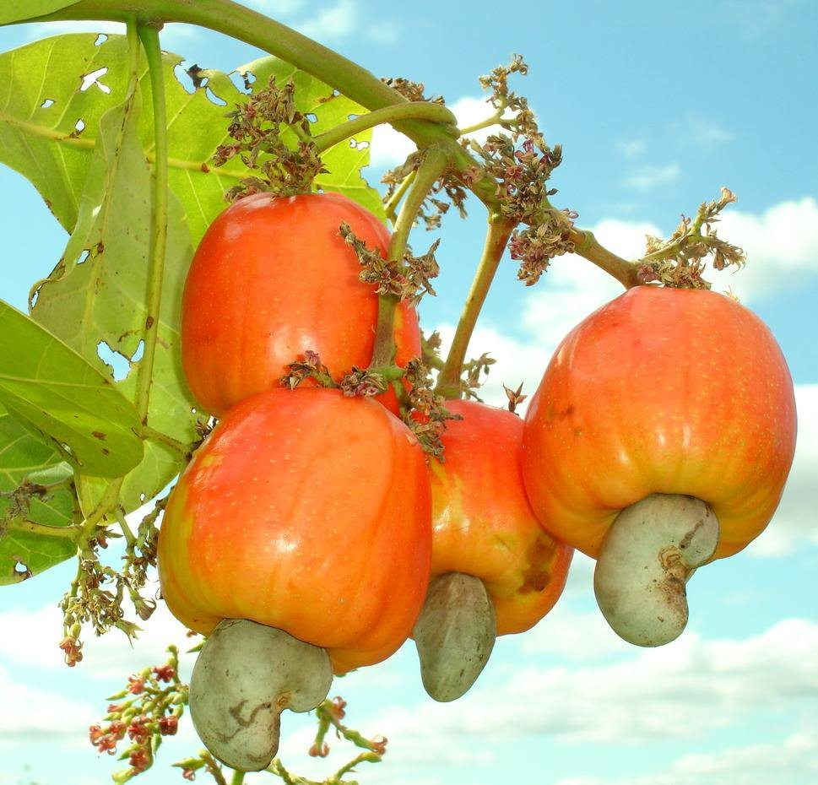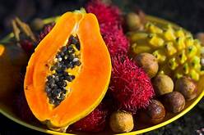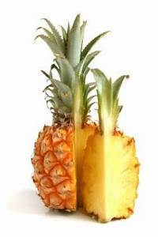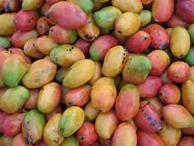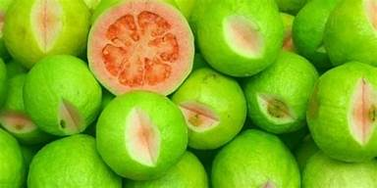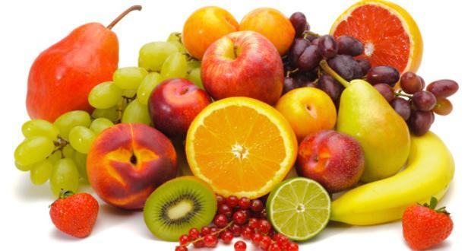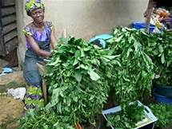
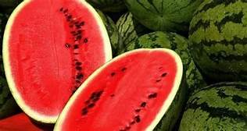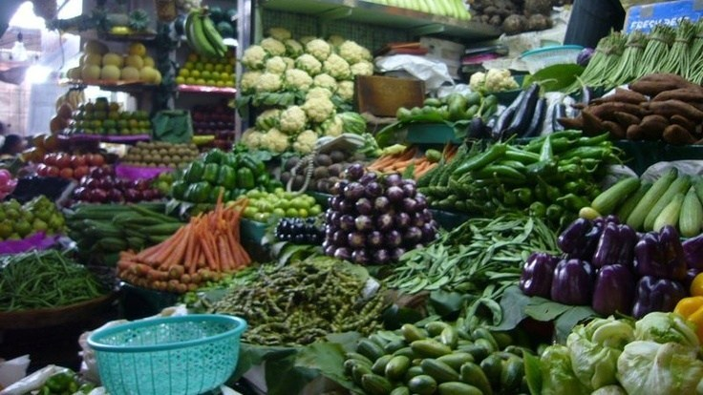

Foods rich in Vitamins and minerals

- Minerals: Minerals help in normal functioning of the body. Examples of minerals are calcium, iron, phosphorus, magnesium, copper, selenium, zinc, sodium, phosphorus, chloride and iodine. Foods that are rich in minerals are milk, soft bones, vegetables, beans, meat, liver, yoghurt, cereals and legumes.

Put the text for vitamins and minerals together and put the pictures together.

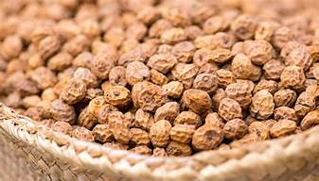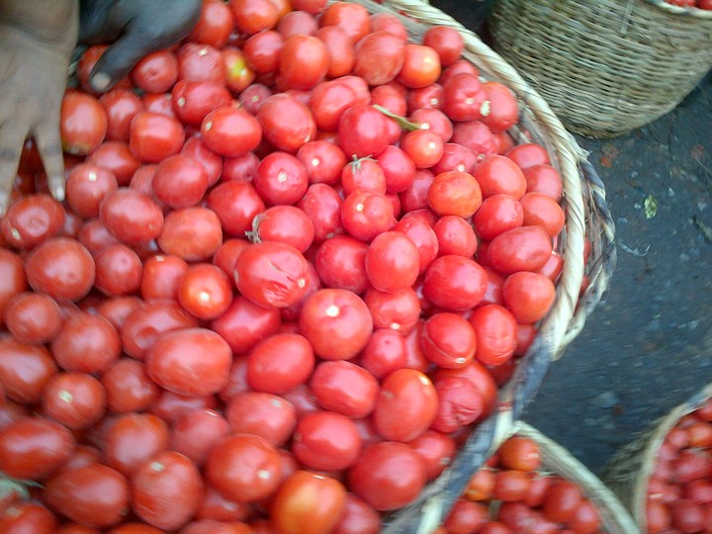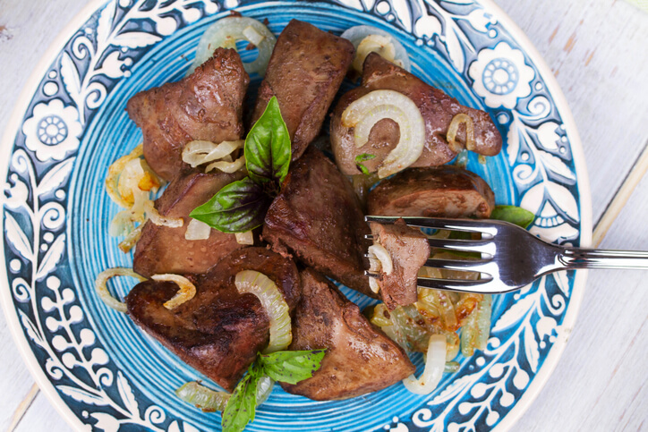
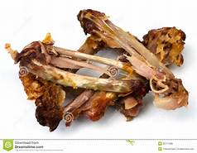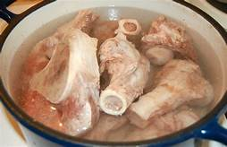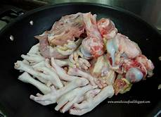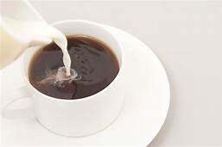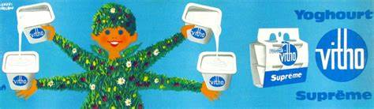delete and insert local milk.
Foods rich in Minerals

- Water: Water helps in digestion of food and other body functions . Water comes from drinking water, the food we eat and all the fluids we take like tea, , milk, juices and beverages

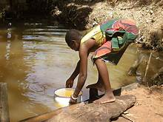 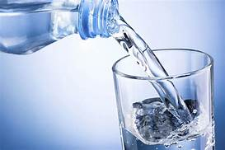insert well water
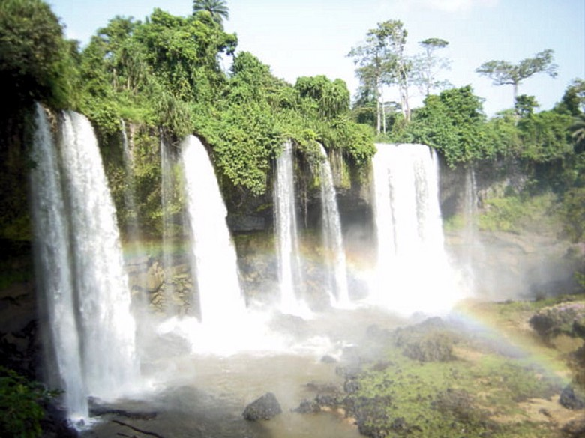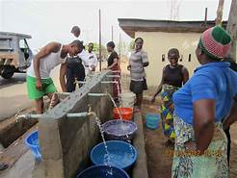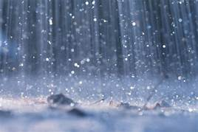

Sources of Water

UNIT 3: FOOD GROUPS

Foods are grouped into four according to the major nutrients they supply to the body. The food groups help us to make good choices when planning meals. A good meal should contain at least one food item from each food group. The food groups are;

Group 1: Starchy roots, tubers and cereals e.g. yam, cocoyam, cassava, rice, maize, wheat and potatoes
Group 2: Fruits and vegetables e.g. oranges, mangoes, pineapple, fluted pumpkin leaf, carrots and green vegetables.
Group 3: Meat, fish, milk, poultry, legumes, nuts and seeds.
Group 4: Fats and oils.

Meat, fish, poultry, milk, legumes

Fats and oils
Vegetables

Fruits

Roots, tubers and cereals
Insert IYCF pictures

Food Pyramid

The food pyramid shows the food groups and the proportion that should be taken in the meal. The position of each food in the pyramid shows the proportion of the food to be included in a meal. Examples roots, tubers and cereals are at the base of the pyramid. They should be included in large quantities in a meal. Fats and oils are at the tip of the pyramid. They should be taken sparingly. A meal that contains at least one food item from each food group in the right proportion and quantity is called adequate diet.

Activity:

List foods that could be combined to form an adequate meal

Example

1.Yam and palm 2.Yam, vegetables, bean, crayfish palm oil, and orange
999
UNIT 4: NUTRITIONAL NEEDS OF DIFFERENT AGE GROUPS
Infants (0 – 12 months)
Infants grow very fast and need a lot of nutrients to be healthy. The first 6 months of the infant’s life is very important and the baby has specific nutrient needs. The infancy period is divided into two as follows:
0 – 6 months
7 – 12 months

- Infants 0 – 6 Months
Breast milk alone is what the infant needs at this stage. Breast milk contains all the nutrients the baby needs for the first 6 months of life.. Breast milk also protects the baby against infections. The baby should not be given any other food or fluid including water except breast milk until 6 months old.

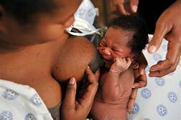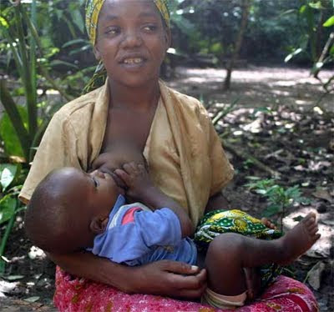
Insert pictures with proper attachment.
A mother breastfeeding her baby

- Infants 7 – 12 Months Summarise
The mother should continue to breastfeed her baby. At this stage, breast milk alone is not enough to provide all the nutrients needed by the baby. The baby should be given other foods (complementary foods) in addition to breast milk. The complementary food helps to make up the nutrients the baby gets from breast milk. The complementary food given to the baby should be soft and semi solid. Home prepared complementary food like fermented maize gruel (akamu or ogi) with some protein foods like groundnuts or soybeans or crayfish added could be given to the baby. The baby should be given some fruits and vegetables. As the baby gets older, he should be given some solid foods like soft food to swallow with draw soup (okra or ogbono). The pap could be given with soft moin-moin.

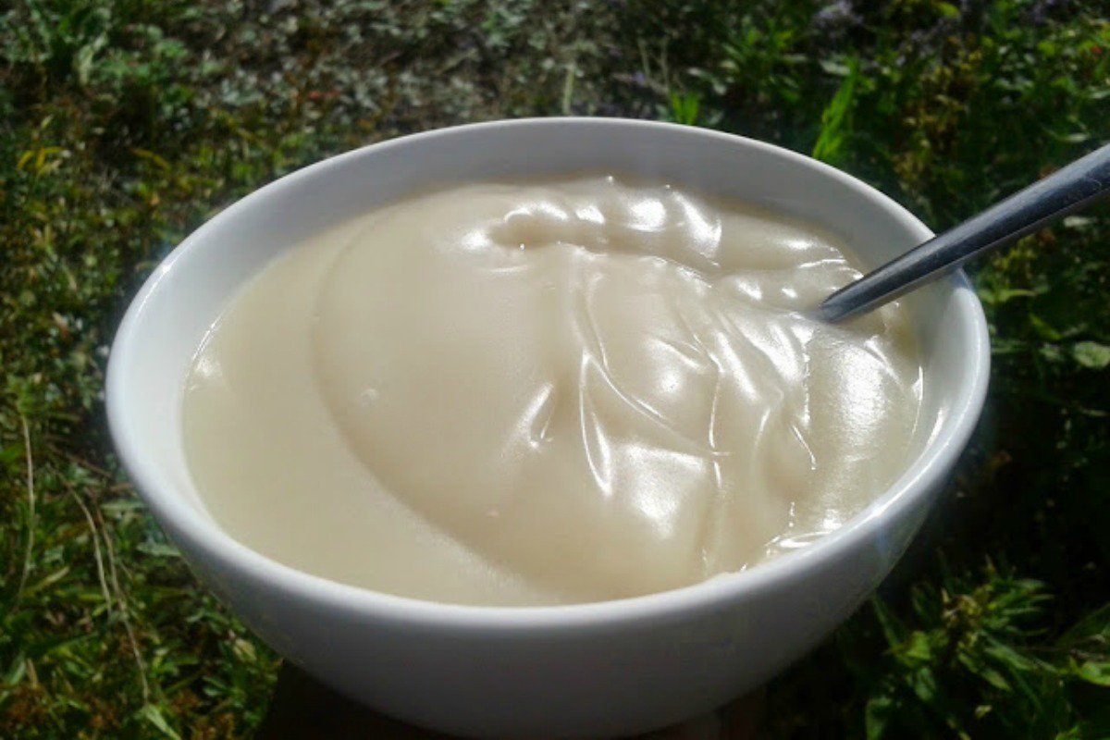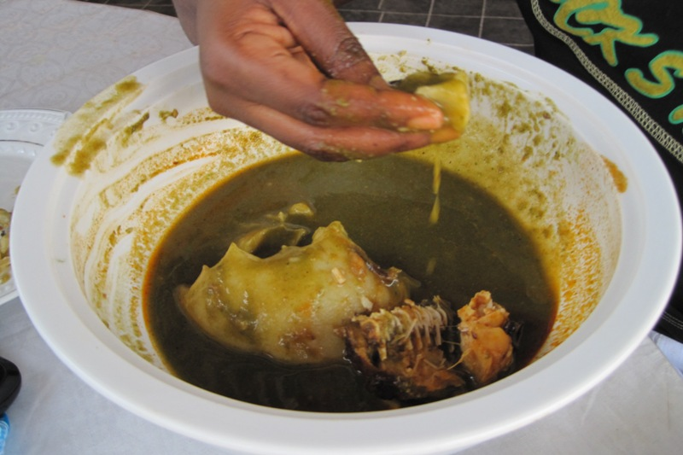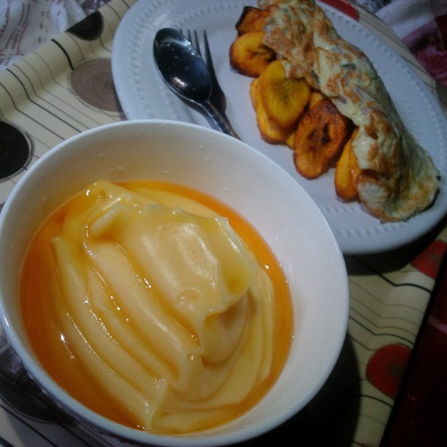

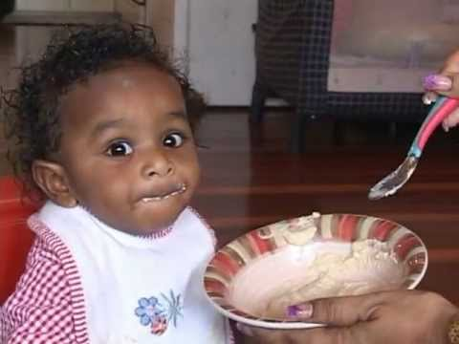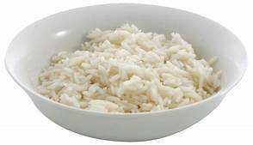
Complementary Foods

- Toddlers (13 – 24 months)
The mother should continue to breastfeed the baby until 2 years of age. This is because the breast milk provides the child with valuable nutrients.. Three nutritious meals and two snacks should be e given in addition to breast milk.

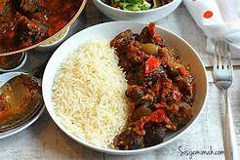

Varieties of Complementary foods given to toddlers

- Pre-School Children (2 – 5 years)
Children at this stage should be given foods in their own plates to ensure enough in-take of food and nutrients. They should be given enough fruits, vegetables and protein foods. Pre-school children should eat food 3 – 5 times and take snacks 2 – 3 times daily. Pre-school children should not take a lot of candies and sugary foods, which could cause tooth decay.

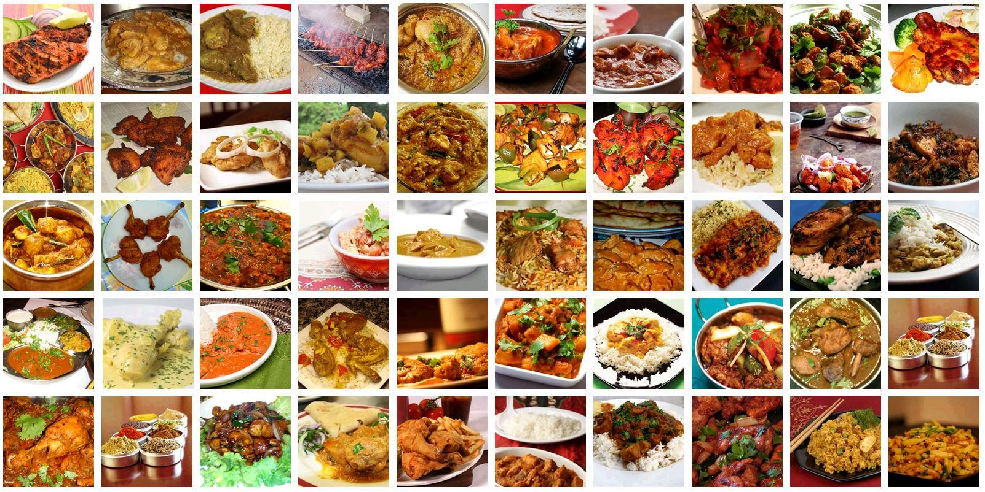
Insert indigenous foods and snacks

Variety of Foods for pre-school Child

- School Children (6 – 11 years)
School children should be given an adequate diet. This is because the food we eat affects the way we learn. A hungry child will not do well in the class. The foods should be rich in all the nutrients. They should also be given nutritious snacks at least two times a day.

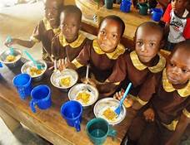

School children eating nutritious meals and snacks

- Adolescents (10 – 19 years)
Adolescents grow very rapidly. They need a lot of nutrients to help them grow well. Adolescents should eat adequate diet with foods selected from each food group. They should eat regular family meals. Some adolescents eat a lot and gain too much weight. This should be avoided. Some adolescents especially girls would like to reduce their weight and eat very little. This habit is not good because they will not get enough nutrients for growth. Snacks and soft drinks should not be taken in place of main meal as is practiced by some adolescents. This is because they will not get enough nutrients to help them grow well. Adolescents should take a lot of fruits and vegetables to ensure healthy growth.

Insert appropriate pictures 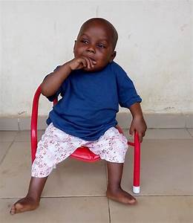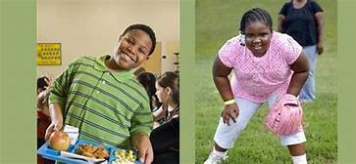

An Overweight Boy An Overweight Girl

- Adults (Male and Female) (20-59yrs)
Adults should eat adequate diet at least 3 times a day to maintain good health and productivity Adults should avoid eating too much food so that they will not gain too much weight and become obese. They should eat a lot of fruits and vegetables with the meal.

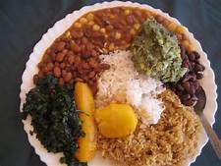

Adequate Diet for an Adult

- Pregnant and Lactating Mothers
Pregnant and lactating mothers should eat adequate diet made up of a variety of foods from the different food groups. They should take a lot of fruits, vegetables and water.

- Elderly ( 60 yrs and above )
The elderly are the old people who are above 60years. As people grow old, the activities of the various organs in their body are weakened. The digestive system is no longer very active. Old people should eat small but frequent meals prepared from variety of foods.

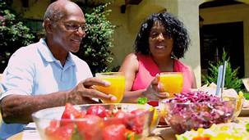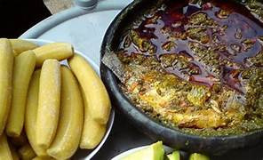

An Elderly eating a variety of food

UNIT 5: DIET RELATED HEALTH RISKS AND DISEASES

1.1 overnutrition [Obesity and Overweight]
An individual that eats too much food will gain excess weight. This would lead to obesity. Obesity is a disease caused by too much gain in weight. This is a form of malnutrition known as overnutrition.

Picture of an Obese teen Under nutrition[Underweight]

Anybody who eats very little food would loose weight and become underweight. Underweight is a nutrition problem (malnutrition) caused by taking very little food in a meal. Underweight is a form of malnutrition known as undernutrition.

Insert a picture of a low birth weight child

Growth Monitoring
Growth monitoring is a process of assessing the growth of the child counselling the caregiver to sustain healthy growth and development of the child . The weight, height and mid upper arm circumference of the child are taken at regular intervals. Growth monitoring helps to know if the child is gaining or losing weight.

Body mass Index (BMI) for Adolescents and Adults

This is used to assess if an adolescent or adult is under weight, normal, overweight or obese.
To check if you are underweight or overweight you will take your height and weight measurements. You then use the measurements to calculate your Body Mass Index (BMI). The BMI is calculated by dividing weight in kilograms by the square of height in meters.

BMI = Weight (kg)
Height² (m²

The result is compared with the standards as follows
Insert corrected table
BMI | Category
<16.00  16.00 – 16.99  17.00 – 18.49  18.50 – 24.99  25.00 – 29.99  30.00 – 39.99  >40.00 | Underweight  Severe underweight  Moderate underweight  Mild underweight  Normal (healthy weight)  Overweight  Grade I (over weight)  Grade II (Obese)  Grade III (Obese)

A girl taking her height A boy taking his weight
Measurement Measurement

Activity: Take your height and weight measurement and calculate your BMI.

Physical Activity
Everybody should do regular physical activity to maintain a healthy weight and good health. Physical activities include walking, running, household chores, exercise and play. Children should be involved in a lot of exercise through play activities in a safe and open environment.

Insert picture

Children playing in an open environment

Different Lifestyles
Our lifestyles show the way we live our lives. Our life styles could be a healthy lifestyle or unhealthy life styles.

Healthy Lifestyle
Taking exercise and moderate eating of an adequate diet are healthy life styles. They would lead to good health.

Insert pictures

A boy taking exercise as a healthy lifestyle

Unhealthy Lifestyles
Smoking, use of unprescribed drugs, excessive intake of sugar, salt, fats and oils are unhealthy life styles. They could lead to poor functioning of the body, diseases and death. We should avoid unhealthy life styles so that we would not suffer from diseases and die.

Eating too much fats and oils in the food is an unhealthy lifestyle.

iii. Diet Related Non Communicable Diseases
Diet related non communicable diseases could be caused by eating inadequate food and living unhealthy lifestyles. Diet related non-communicable diseases include diabetes, heart diseases, hypertension, cancer, overweight, and obesity, which could lead to early and sudden deaths.

MODULE 2: EATING HABITS, CULTURAL AND SOCIAL INFLUENCES

LEARNING OBJECTIVES:
At the end of this module, pupils should be able to:
- Explain eating habits or food habits
- Give examples of the different types of eating habits
- Explain food taboos and fallacies
- List the factors that affect food choices

- Describe a nutritious a meal
- List the importance of regular meals times and snacks
- List the importance of eating indigenous foods
- State the effect of alcohol on nutrition [consider removal]

UNIT 1: EATING HABITS AND VALUES

1.1 Eating Habits
Eating habits or food habits is the way people eat, which foods they eat and with whom they eat as well as the ways people obtain, store, use and discard food. Food habits are influenced by individual, social, cultural, religious, economic, environmental and political factors.

1.2 Types of Eating Habits
There are 2 types of eating habits:
  - Good eating habits
  - Bad eating habits

Good Eating Habits
Good eating habits include:
- Eating three adequate meals a day
- Taking nutritious snacks
- Eating in a comfortable place
- Eating fresh fruits and vegetables
- Eating food immediately after cooking
- Not eating spoilt food

Activity:
Show an example of good eating habit by listing foods from the different food groups that could be taken in one meal.

II. Bad Eating Habits
Bad eating habits include
- Skipping meals and snacks e.g. not eating breakfast before coming to school.
- Eating only one type of food always e.g. eating only rice every day.
- Taking unhealthy snacks in place of the main meal e.g. taking carbonated drinks (soft drinks) and buns in place of an adequate lunch or breakfast.
- Eating cooked food that has been kept for a long time (more than 2hrs?).

Activity:
State some bad eating habits that you practice.

Food Taboos and Fallacies
Food taboos and fallacies give a false guide on foods that should not be eaten. The food taboos are influenced by culture, beliefs, religion and customs. Example of food taboo is that pregnant women are not allowed to eat snail in some cultures. This is because it is believed that the baby will behave like a snail and be drooling saliva from the mouth. Food taboos are not good because it prevents people from eating nutritious foods. The pregnant woman who is not allowed to eat snail is denied of the important nutrients like protein, vitamins and minerals obtained from snail.

Activity:
List the food taboos in your community

Alcohol and Nutrition
Alcohol affects the way the body uses food nutrients. Too much intake of alcohol would cause malnutrition because the alcohol would not allow food nutrients to function properly in the body. Alcohol should be avoided..

Insert picture

UNIT 2: MEALS AND MEAL PATTERN

Meal
Meal is the food we eat. We should eat variety of foods in a meal. A nutritious meal should contain at least a food item in appropriate proportion from each of the food groups. This would provide variety in the meal and also ensure that the meal is adequate. Enough water should be taken with the meal so that the foods would digest properly.

Activity:
- Give an example of a meal and the foods that make up the meal
- State if the meal is adequate or not

1.2 Meal Times
We should have regular times for eating food. This will help the body to function properly and prevent diseases. If food is not taken at regular times, the body may develop some diseases like ulcer. Foods should be taken at least 3 times a day. We should allow 5 – 6 hours interval after one meal. The meal time could be 6 – 7 am in the morning, 12 – 2pm in the afternoon and 6 – 7 pm at night. It is important to eat food at these times because the body system would be set to digest and absorb food at these periods. It is not good to eat food late at night because the digestive system should be allowed to rest while sleeping.

Meals as Snacks
Meals could be taken as snacks. Snack is a small amount of food taken between main meals. Snacks should be nutritious to provide energy, protein and other nutrients. Examples of snacks include fruits and vegetables in season, groundnuts, roasted yam, plantain and corn.

Insert pictures of healthy snacks

UNIT 3: FOOD HABITS OF DIFFERENT ETHNIC GROUPS

Indigenous foods and values.
Different ethnic groups have their Indigenous foods. Some of the Indigenous foods are eaten during festivals. Examples include Okpa, akara, Tuwo,

Inser pictures

1.2 Different Indigenous Foods

- Local Diets
Local diets are foods prepared locally by the different ethnic groups for example tapioca produced from cassava by the Igbos, . “amala” prepared from yam by Yorubas and tuwo by Hausas. These local diets are very nutritious because most of the food ingredients are fresh and locally available..

Insert of pictures of indigenous meals

1.3 Changing Food Pattern
Many people are moving to the urban centres and as such,a lot of people no longer eat most of the nutritious indigenous diets. Mothers/caregivers are too busy to cook at home,,they buy processed foods from fast food vendors. It is advisable that families prepare meals at home using nutritious indigenious foods.
Our grandparents ate a lot of nutritious indigenous foods which made them strong and healthy. It is necessary to eat these indigenous foods because they contain a lot of nutrients and substances that would make us healthy.

Activity:
List the local foods in your area.

Start now
UNIT 4: FACTORS INFLUENCING FOOD CHOICES

Some of the factors that influence our food choices include:
- Food Availability and Season: The season of the year would make some foods to be available. We should choose our food from those foods that are available within a season. Examples: during dry season, oranges are available and it could be our major choice of fruit for the meal along with other fruits in season.

- Peer Groups: Peer groups or our friends could influence our choice of food. We should be careful in choosing foods based on what our friends tell us or do because some of them do not know how to select adequate diet from the food groups. Example: your friends may be bringing plain noodles to school as lunch, but your noodles is prepared with vegetables. Do not try to copy what your friends are doing because noodles when eaten with vegetables,eggs and taken with fruits provide some minerals and vitamins which will help the body to be healthy.

- Affordability: Affordability has to do with ability to buy food. We should make the choice of our food based on the money available for feeding. Many inexpensive foods contain a lot of nutrients. Example: moin-moin and pap could be taken as dinner instead of the very expensive foods from the super markets.

- Time Available: The time available should be considered before choosing a food. If you are preparing to go to school early in the morning, you will choose a food that will not take a lot of time to prepare. Example: cooking fried rice in the morning is not good because you will require a lot of time to prepare the vegetables and that could make you go to school late.

- Ease of Preparation: In choosing foods we should consider the preparations that need to be done. We should buy foods that are easy to prepare. Example: if we want to prepare akara, clean your beans ahead of time to reduce preparation and cooking time.

- Gender: The gender of the individual should be considered when choosing a meal. Example: males require a little bit more energy than their female counterparts, hence, require bigger portion.
- Health Status of Individuals: The health status of an individual affects the choice of food. Sick people need soft and easily digestible food. Some illnesses are associated with loss of appetite (e.g. malaria) while others require special diets (e.g. diabetes)
- Age of Individuals: The age of the individuals should be considered when selecting food. Example;: children need to eat foods rich in protein. This is because children are still growing and developing, their bodies need more protein than adults.

- Availability of Cooking Utensils/Fuel: The cooking utensils available in the home may affect the choice of food prepared. Some foods require the use of specialized utensils such as ovens, steamers and pressure pots. You should also consider the cooking fuel like gas, kerosene, firewood, charcoal that is available.
- Skills and Knowledge of the Cook: We should consider the skills and knowledge of the cook when choosing a particular meal.
- Food Allergy and Intolerance: Food allergy and intolerance has to do with how the body reacts when it takes certain foods. Some individuals cannot tolerate some foods. This factor has to be considered when choosing a meal.

MODULE 3: FOOD AND EMOTIONAL DEVELOPMENT

Learning Objectives:
At the end of this module, pupils should be able to:
- List different types of food tastes
- Describe how tastes determine food preferences
- Explain the importance of making wise decision on what to buy, eat and drink
- Explain how adequate diet helps develop good body image and self esteem.

UNIT 1: SENSORY PERCEPTION OF FOODS
Food preference is influenced by food tastes Some people like sweet food while others would prefer foods with some bitter taste.The different types of foods we eat have different tastes. Example bitter leaf has bitter taste while sweet potato has sweet taste. Lemon has sour taste while orange has sweet taste. The tastes of the foods affect our food preferences or choices.

Activity 1

List 10 types of food and their different tastes

Activity 2

List 5 types of food you like and give reasons for your preference.

UNIT 2: BODY IMAGE AND SELF ESTEEM

Body Image and Adequate Nutrition
Adequate nutrition affects individual’s appearance. Eating too much food can lead to overweight which affects , body image and self esteem. Eating too little can lead to loss of weight which will also affect body image and self esteem

Insert pictures

Over Weight Child (Obese)

Insert pictures

Under Weight Child

In addition to adequate diet, genetics and environment affect our body shape and sizes. Genetics has to do with the type of genes we inherit from our parents. A child whose mother is fat may also grow fat. The food environment, that is, what is around us could also make us fat or thin. If you eat a lot of ice cream because it is always sold in front of your school, you may be very fat and this will make you have a bad body image and other people might be laughing at you and you will not be proud of yourself (low self-esteem). It is important that we eat adequate diet because it can help to modify our genetic make up. It is not good to laugh at children who are very fat or thin, very short or tall because part of the reason for the poor body shape and size might be due to the child’s genetic makeup. We should rather encourage them to eat adequate diet so that it can help them develop good body image .

Under Weight Child Normal Child Over Weight Child

We should make wise decision on what to buy, eat and drink to avoid under weight and over weight (obesity). We should be responsible children and assist in household chores like sweeping, washing plates, cars and clothes, fetching firewood and water cooking looking after the younger ones and helping with feeding younger children, , dressing ourselves and taking our bath. These are all forms of physical activities, which could help us develop good body size.
MODULE 4: HYGIENE, SANITATION AND NUTRITION

Learning Objectives :
At the end of this module, pupils should be able to:

- List the sources of water
- Mention the properties of safe water
- List the sources of safe water
- Mention the importance of maintaining good hygiene during food preparation
- List the causes of diarrhoea and other water borne diseases
- List the symptoms of diarrhoea and other water borne diseases
- Describe how to handle persons suffering from diarrhoea and other water borne diseases
- Demonstrate how to prepare oral rehydration solution

UNIT 1: WATER

Water is a substance made of hydrogen and oxygen elements.

Unit1;Types of water

Safe water should be fee from contamination by microorganisms, particles and dirt’s. It should be clear, tasteless, colourless and odourless.Unsafe water is contaminated by microorganisms and harmful substances. It may have colour, taste and odour. It is not good to drink unsafe water.

1.2 Sources of Safe Water
Safe water could be obtained from pipe-borne water, spring water, rain water harvested in the open air and water from bore-holes.

Insert pictures from pry.4 Sources of water

Activity:
- List the sources of water in your home
- State the sources that give safe water

Sources of Unsafe Water
Unsafe water could be obtained from pond, lake, stagnant pools, wells, rivers, lagoons and seas

Insert pictures

(diagram)Sources of Unsafe Water

Water-borne Diseases
Water-borne diseases are diseases that are contracted from using water that is contaminated by micro-organisms, chemicals and other pollutants. Examples include; dysentery, cholera, typhoid and schistosomiasis.

1.5 Role of Water in the Body

Water helps the body to function well and be in good nutritional status. It helps to maintain body temperature, digestion, absorption and excretion. Waste products that could be harmful to the body are removed with water in form of urine.

UNIT 2: FOOD SAFETY AND HYGIENE
Foods should be prepared in a clean environment using clean hands, utensils and cutlery to avoid contamination by microorganisms. Contaminated food could cause diseases like dysentery, cholera, diarrhoea and typhoid. Germs could be found in many places and could be prevented from spreading by covering our mouth and nose while coughing and sneezing. Proper covering of food will prevent flies from perching on it

Insert pic of Coughing with mouth covered Sneezing with nose covered

UNIT 3: DIARRHOEA AND OTHER WATER BORNE DISEASES
Diarrhoea
Diarrhoea occurs when one has 3 or more loose stools within 24 hour period . It is caused by food poisoning, viral or bacterial infections and parasites. Oral Re-hydration Therapy (ORT) is used to replace fluid lost from the body . ORT is the use of appropriate measures of salt, sugar and water mixed together to form a solution. This solution known as salt –sugar solution is taken by drinking

1.2 Preparation of the Salt-Sugar Solution

The items required in the preparation of the solution include clean water, salt, clean bowl, cup, 3mls spoon, clean bottle or 600ml container, sugar (granulated or cubes), towel, soap and wash-hand basin. The process of preparation involves ;
- Wash hands with soap and water
- Dry the hand with clean towel
- Pour two-coke bottle full or one beer bottle full (600mls) of clean water into a clean bowl
- Add either 10levels of 3ml spoon of granulated sugar or 5 cubes into the measured water
- Add 1 level of 3ml spoon of salt into the same water
- Stir the contents until well dissolved.

The solution should taste like tears or coconut water and must be used within 24 hours of preparation.

Insert picture

A child suffering from diarrhea

Insert picture

A woman preparing ORS

Activity:

Prepare ORS for a child suffering from diarrhea
1.3 Typhoid Fever
Typhoid fever is a serious illness associated with fever which is caused by salmonella bacteria. The bacteria are deposited in water or feed by a human carrier and are then spread to other people in the area.

One suffering from typhoid fever has poor appetite, headaches, fever, diarrhoea and feels very weak. The illness could last for 4-6 weeks. Typhoid fever is treated with antibiotics that kill the salmonella bacteria.

1.4 Cholera
Cholera is a serious diarrhoea illness caused by infection of the intestine with the cholera bacterium. The infection is often mild or without symptoms, but sometimes can be severe. The symptoms include profuse watery diarrhea, continuous vomiting and leg cramps.
The loss of water leads to dehydration and shock and without early treatment, death can occur within hours. A person may get cholera by drinking unsafe water or eating food contaminated with the cholera bacterium. In an epidemic, the source of the contamination is usually the feces (stool) of an infected person. The disease can spread rapidly in areas with inadequate treatment of sewage and unhygienic source of drinking water.
Cholera can be treated by immediate replacement of the fluid and salts using ORT

1.5 Dysentery
Dysentery is an infection of the intestines resulting in severe diarrhoea with presence of blood, pus and mucous in the faeces usually accompanied with abdominal pain.

Bacterial infections are the most common causes of dysentery with poor hygiene and sanitation as risk factors. . The main symptoms are:
- frequent near-liquid diarrhea flecked with blood,
- mucus or pus.
- sudden onset of high fever and chills,
- abdominal pain, cramps
- bloating,
- flatulence (passing gas),
- urgency to pass stool with feeling of incomplete emptying,
- loss of appetite,
- weight loss,
- headache,
- fatigue,
- vomiting and
- dehydration.

Antibiotics are usually used to treat dysentery and use of ORS to replace the fluids lost from diarrhea. In mild cases, soft drinks, juices and bottled water will be enough. Most severe diarrhea should be treated with salt and sugar solutions. Dysentery can be prevented to some extent by practicing proper hygiene.

UNIT 4: WASTE DISPOSAL

Unit 4:1: What are Wastes?

Wastes are unwanted or unusuable materials discarded after primary use.

Unit 1:2 : Types of Waste

Wastes can be divided into:

- Solid Waste
- Liquid Waste
- Recyclable Waste
- Harzardous Waste
- Organic Waste
- Domestic waste

1.3 Domestic wastes include all household
wastes, which is composed of garbage and rubbish that normally originate in a home. Domestic waste may contain a significant amount of toxic or hazardous waste.

Unit 1:4 Use of Organic Wastes
Organic wastes are those wastes that could be used for livestock feeds and for preparation of compost manure.

Unit 1:5 Safe Ways to Dispose Wastes
Domestic waste should be disposed in distances far from the premises of human habitation or designated during sites.
The wastes could also be
- burnt,
- buried or
- recycled.
Waste should be disposed properly to decrease the occurrence of common communicable diseases like dysentery, diarrhoea and cholera.

Insert Pictures of Wastes’ Disposal Methods

MODULE 5: FOOD PREPARATION, PRESERVATION AND STORAGE

Learning Objectives
At the end of the module, pupils should be able to:
- Explain the use of recipe in food preparation
- Mention the different methods of food preparation
- Mention the different cooking techniques
- Mention the different preservation methods

UNIT 5.1: PREPARATION TECHNIQUES AND SKILLS
Food is prepared using recipes. A recipe shows the quantity of ingredients required for a certain food preparation and the method of combining the ingredients. During food preparation, it is proper to wear apron and cover the hair.

Some of the preparation methods for common foods include:

- cutting,
- peeling,

- shredding,
- chopping,
- grinding,
- blending,
- pounding,
- blanching,
- stirring and
- grating.

Activity 5:

Demonstrate the recipe for indigenous food preparation and Cake making

UNIT 1.2: COOKING TECHNIQUES AND SKILLS
Simple cooking techniques include;
- boiling,
- frying,
- grilling,
- baking
- steaming,
roasting
UNIT 1.3: FOOD PRESERVATION
Food preservation is the process of preventing food from spoilage. Food can spoil if not well preserved .
Different methods of food preservation include:
- salting,
- smoking,
- drying,
- freezing and
- fermenting
- Canning

Common food preservation methods include:
- salting,
- smoking
- drying
- freezing
- refrigerating
2.
MODULE 6: CONSUMER ASPECTS OF FOOD

Learning Objectives : At the end of the module, Pupils should be able to:
- make wise choice when buying food
- Identify the markets to go to when buying different food items
- Mention the information to look for when buying foods
- Relate food advertisement to adequate diet
- Identify locally produced nutritious foods

UNIT 1: FOOD QUALITY

This is the acceptable form of food that is good for consumption.

The food we eat should be wholesome. It should not show any sign of spoilage. Example: green leafy vegetables should be green. Do not buy the ones that have turned yellowish or black. Buy fresh strong tomatoes and avoid soft and broken ones because they are not wholesome and may have been contaminated by micro organisms. Buy fresh fruits and avoid spoilt ones.

Insert pics of Fresh Foods

UNIT 6.2: FOOD SHOPPING
Foods could be bought in an open market or super market. In an open market, there is the opportunity to price and bargain. In a super market, prices are tagged to items and you do not bargain.
To make a good purchase, identify different markets and shops/stalls where different foods could be bought at good prices. Example: cassava is always cheaper in the markets located in the areas of production..

Activity
Take children to an open market and a super market.

Activity:
List 10 foods sold in
- Open market
- Super market

UNIT .3: FOOD PACKAGING

1.1What is food packaging
Food packaging is the process of protecting food from damage, contamination, spoilage, pest attack from production to consumption.

Foods could be packaged for sale or preservation using
, basket, plastics, foils, cans, cartons and paper. fruits and vegetables can be packaged using baskets, plastic materials, cans. Meat and fish products are packaged in cartons. There are cannned foods like milk, fruit juices and drinks

When buying packaged foods, it is good to read the information on food labels. Things to look out for include:

- manufacturing and expiry dates;
- NAFDAC registration number: Foods with NAFDAC registration number have been approved by NAFDAC to be fit for human consumption. Do not buy foods without NAFDAC registration number because they have not been approved to be safe for consumption;
- nutrition information: This will help you know the nutrients contained in the food so that you can make wise choice of adequate diet.

Insert picture showing nutrition information, NAFDAC Number & Manufactiuring/Expiry dates

UNIT 4 ADVERTISING AND MARKETING

Most often, adverts are meant to persuade customers to buy food item. We should be very careful with adverts. We should not be carried away with what the manufacturers say in the advert. In buying food, we should consider how it is going to make our diet adequate.

UNIT 5 CONSUMPTION AND ENVIRONMENT
It is preferable to buy locally produced food because they are fresh and have not been processed. Processing of food could lead to loss of some valuable nutrients.. It is better to eat whole fruits than just the juices.

Insert pictures of whole Foods

Locally produced foods

Locally produced Foods

MODULE 7: FOOD PRODUCTION, PROCESSING AND DISTRIBUTION

Learning Objectives :
At the end of this module, pupils should be able to:
- Name the main sources of food
- Describe different methods of food production
- State the importance of farms and gardens to adequate nutrition
- Describe different methods of food processing
- Give examples of processed food
- Give four reasons why foods are processed
- List four advantages and two disadvantages of food processing
- List five factors that can influence family food supply

- Explain the effects of environmental factors on food production and nutrition
- Explain genetically modified foods
- List the advantages and disadvantages of genetically modified foods
- Define HIV/AIDS
- Explain the role of nutrition in managing HIV/AIDS

UNIT 1: FOOD PRODUCTION

1.1 Sources of Foods
Food could be obtained from plants and animals. Animals depend on plants for food. Man depends on both plants and animals for food. This constitutes what we call food chain.

Insert diagram of food chain

Food Chain

1,2 Origin of Certain Foods

Food have their historical origins. Example Irish potato originated from Ire-land in Europe. It is believed that rice cultivation began simultaneously in many countries over 6500 years ago. The first crops were observed in China around 5,000BC as well as in Thailand around 4,500BC. From there rice cultivation expanded to other Asian counties like Korea, Japan, Pakistan, Sri Lanka, Philippines and Indonesia.
The Asian rice (Oryza sativa) was adopted to farming in the Middle East and Mediterranean Europe around 800BC. After the middle of the 15th century, rice spread through Italy and then France, later to all the continents during the great age of European exploration.
Rice is so important in Asia, where it originated that the same term refers to both "rice" and agriculture. In many of their local diets the verb "to eat" means to "eat rice".

Insert Pictures of rice

How Foods are produced

Foods could be obtained through various ways namely farming, fishing, hunting and from factories.

Farming – Foods that could be obtained from farming include yam, cassava, beans potato, corn, fruits and vegetables.

Fishing – Foods that could be obtained from fishing include fish and other sea foods.

Hunting – Foods that could be obtained from hunting include bush meats like grass cutter.

Factories – Foods that could be obtained from factories include canned foods like fruit juices, canned tomatoes, bottled and canned drinks. We can also obtain vegetable oils, flour, sugar, salt tea, coffee and all the beverages from factories.

Foods obtained from Farming

Foods obtained from Fishing

Insert picture

Foods obtained from Hunting

Insert pictures

Foods obtained from Factories

Tools used in Food productions
Cultivation – In food cultivation the following tools are used; hoe, machete, digger.

Insert Pictures

Hoe Machete Digger

Hunting – The tools used for hunting include guns,catapult, traps, bows and arrows.

Insert pictures

Guns Catapult

III. Fishing – The tools used in fishing include nets, hooks and baskets

Insert picture

Nets Baskets

UNIT 2: FARMS AND GARDENS FOR IMPROVED NUTRITION

School Farms and Gardens
Keeping school farms and gardens help to improve nutrition. This is because a lot of fresh foods, which are nutritious, are obtained from the school farms and gardens. A lot of fresh vegetables could be obtained from school garden. School farm can produce poultry, egg, fish, goat, sheep, cow, snails, pigs, corn, rice, beans.

Insert pictures

Vegetables from School Garden Animals from School Farm

1.2 Home Gardens

Keeping home gardens help to improve nutrition. This is because the vegetables produced in the home garden could be harvested and used fresh for food preparation. Vegetables could be harvested anytime from the home garden for use. This will help to improve nutritional adequacy of our diets and save cost.

Insert pictures

Home Garden
Fish Pond
Keeping fish pond could help to improve nutrition. This is because the fish grown in the fish pond could be harvested as the need arises and used to prepare nutritious meals.

Insert pictures of fish pond

Fish Pond
Poultry
Keeping poultry is a good way to improve nutrition. This is because the chicken could be killed and used as meat. The chicken could also lay eggs. Many nutrients like protein and vitamins could be obtained from egg. Egg is a very good food for growing children because of its rich nutrient content.

Insert pictures of poultry farm and egg.

Chicken Egg

UNIT 3: FOOD PROCESSING

Food Processing
Food processing is the techniques used to transform raw ingredients into food or to transform food into other forms for consumption by humans or animals. This could be done in the home or by the food processing industry. Examples are processing cassava into garri, processing yam into yam flour and processing fruits into fruit juices.

Purpose of food Processing
The reasons for processing food include
- Preservation – Processing food helps to preserve the food to last for a longer period, and to be available at all times. Example is the . production of fruit juice from fruit in season. The juice is available at all times.
- Produce Convenience Food – convenience foods are foods which do not require extensive preparations. During processing, most of the preparations have been done on the food. Therefore use of convenience food saves time and energy. Example, production of yam flour for preparing pounded yam. To prepare pounded yam from the yam flour is easy, convenient and saves times. It only requires boiling water and stirring the yam flour.

Activity: List other convenience foods produced by processing

- Removes Harmful Substances – Processing helps to remove harmful substances from raw materials. Example, eating some types of raw cassava could cause harm to individuals but when the cassava is processed into garri by fermentation, the harmful substances are removed.

- Kills Microorganisms – Processing helps to kill microorganisms, which could cause harm to individuals if consumed with the food. During production of milk, the milk is pasteurized to kill all harmful microorganisms before canning.
- Make Food Easier to Transport – Processed foods are easier to transport across long distances. Example, fruit juices are easier to transport than fresh fruits.
- Provide Ready-to-Eat Food – Processing helps in producing ready to eat foods that may not require further cooking. This is particularly an advantage during long travels . Example sardine, corned beef.
- Provide Food Items to be sold in supermarkets – Food processing helps in production of foods that would be sold in super markets Example all canned foods, biscuits, processed breakfast cereals (oat meal, cornflakes, golden morn).

- Adding Extra Nutrients to Food – During food processing extra nutrients are added to food. Example milk is fortified with vitamins and minerals during processing.

Disadvantages of Food Processing
- Leads to loss of nutrients. Example vitamin C is destroyed by heat.
- Some of the preservatives used during the processing could be harmful and may cause cancer and other diseases.
- Processed food may be more expensive than the unprocessed because of the cost of processing.

Products of Food Processing
Foods are transformed into other forms during processing.
Examples; yam is processed to yam flour, potato to potato flour, wheat to wheat flour, cassava to garri, maize to maize flour

Activity: Link the processed foods you know with their raw materials.

UNIT 4: FOOD AND NUTRITION SECURITY

What is Food Security ?
Food security is access for all at all times. To a suitable supply of nutritionally adequate and safe food for normal, physical mental development for productive life. To have food security means that families should have enough nutritionally adequate food for all its members.

1.2 Nutrition Security
Nutrition security is attained by individuals to adequate supply of food that would provide all the nutrients needed for good health and development Nutrition security has to deal with meeting individual nutritional needs.

1.3 Different Levels of Food and Nutrition Security
Food andnutrition security applies at different levels namely national, state, community, household and individual levels. Nutrition security applies to individual level.

1.4 Factors That Can Affect Family Food Supply
Different factors affect family food supply. They include:
- Income of the Family – The amount of money that comes into the family will influence the family food supply. If the family has large income, they may buy food regularly and/or in large quantity

- Location of the Family – If the family lives near the market, they may have access to fresh food for their family members.
Family Food Values – If the family has good food values then they will make efforts to have nutritious meals in the home.

Food Availability
The availability of food could differ amongst households and across regions and seasons . This is because households may have different values that would affect their attitude to food. Food availability could also be affected by regions because different foods are available at the different regions and seasons

Activity: List the foods that are available in your region.

UNIT 5: ENVIRONMENTAL ASPECTS IN FOOD PRODUCTION AND NUTRITION

1.1 Impacts of Erosion on Farm Lands and Gardens
Erosion could wash away valuable nutrients like minerals (iron, iodine, magnesium etc) on the surface of the soil. The foods produced from such soil would not absorb enough nutrients from the soil. We should avoid having our farm lands and gardens where there is erosion. This will help preserve nutrients in the soil for use by the plant.

1.2 Impacts of soil and air pollution on food production
When soil is polluted it affects the nutrients in the soil. Some of the valuable nutrients that would be absorbed by plants from the soil could be destroyed by the pollutant. Soil and air pollution could destroy the plant and reduce food production e.g. pollution by oil and gas. Some pollutants can also be absorbed by the plants and transferred to the consumer.

1.3 Effect of Inappropriate Waste Disposal on Food
If waste products are not properly disposed our food could be contaminated by microorganisms present in the waste product. This will cause diseases like diarrhoea or cholera when the food is eaten. Waste products should be properly disposed.

1.4 Effect of Pests, Insects and Rodents on Food Production
Pests, insects and rodents attack crops and reduce food production and availability .

Activity:
Give examples of
- Pests and the crops they attack
- Insects and the crops they attack
- Rodents and the crops they attack

1.5 Impact of Environmental Pollution on Nutrient Utilization
Environmental pollution would interfere with utilization of nutrients.. If the environment is polluted with heavy metals like lead, mercury and cadmium, the pollutants will be deposited in the soil and then absorbed by plants grown in such soils. The heavy metals interact with nutrients and reduce their absorption. Lead is known to interact with calcium and iron to inhabit intestinal absorption.

UNIT 6: EMERGING ISSUES
1.1 What is Genetically Modified Foods?
Genetically Modified Foods (GMF) Genetically Modified (GM) foods are foods derived from genetically modified organisms. Genetically modified organisms have had specific changes introduced into their DNA by genetic engineering
The modification could help improve nutrient content and availability.

Genetically modified foods could be modified to increase nutrient content of the food, or to improve flavour and storage capacity of the food. Genetically modified foods have not been thoroughly investigated to know the effect on health of humans.
1.2 What is the relationship between Nutrition and HIV/AIDS?
HIV – Human Immunodeficiency Virus is the virus that causes AIDS – Acquired Immune Deficiency Syndrome. The disease is a deadly disease of the human immune system. HIV attacks and gradually destroys the immune system, leaving the host unprotected against infection. The affected person is exposed to variety of infections. The virus is contracted mainly through exposure to body fluids for example, blood and semen through sharing of needles and other sharp objects

Adequate nutrition is important in the care and management of HIV/AIDS. This will help the body fight infections. The HIV/AIDS patient should take plenty of fruits and vegetables to boost the immune system.

